1. Write a Program to implement Factory pattern. Use below class diagram.
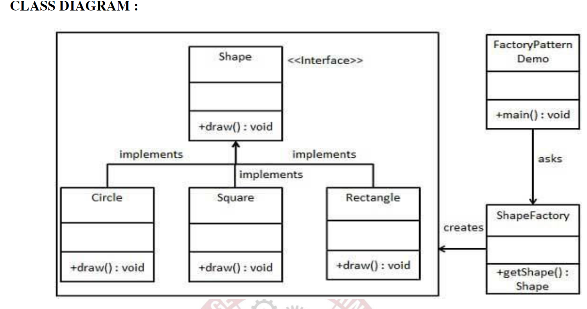

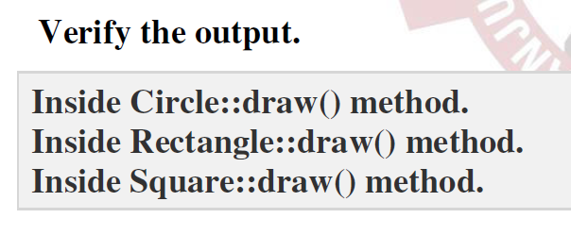

2. Write a program to implement singleton pattern.Use below class diagram for reference.
